Practical No:- 12
Q1.write a program using jpasswordField to set the password character as “#” instead “*”.

import javax.swing.*;
import java.awt.*;

public class JavaApplication3 {

public static void main(String[] args) {
JFrame f=new JFrame("Password Field Example");
JPasswordField value = new JPasswordField();
JLabel l1=new JLabel("Password:");
l1.setBounds(20,100, 80,30);
value.setBounds(100,100,100,30);
f.add(value); f.add(l1);
f.setSize(300,300);
f.setLayout(null);
f.setVisible(true);
}

}
OUTPUT:-
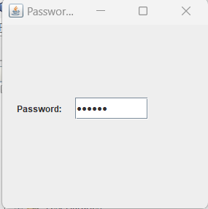

XIII. Exercise
Q1.Write a program using JPassword Field and JTextField to demonstrate the use of user authentication.
import javax.swing.*;
import java.awt.event.*;
public class User_authontication {
public static void main(String[] args) {
JFrame f=new JFrame("Password Field Example");
final JLabel label = new JLabel();
label.setBounds(20,150, 200,50);
final JPasswordField value = new JPasswordField();
value.setBounds(100,75,100,30);
JLabel l1=new JLabel("Username:");
l1.setBounds(20,20, 80,30);
JLabel l2=new JLabel("Password:");
l2.setBounds(20,75, 80,30);
JButton b = new JButton("Login");
b.setBounds(100,120, 80,30);
final JTextField text = new JTextField();
text.setBounds(100,20, 100,30);
f.add(value); f.add(l1); f.add(label); f.add(l2); f.add(b); f.add(text);
f.setSize(300,300);
f.setLayout(null);
f.setVisible(true);
b.addActionListener(new ActionListener() {
public void actionPerformed(ActionEvent e) {
String data = "Username " + text.getText();
data += ", Password: "
+ new String(value.getPassword());
label.setText(data);
}
});
}

}
OUTPUT:-
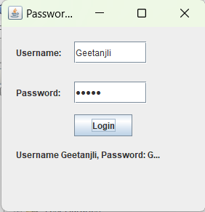
Q2. Write a program using JTextField to perform the addition of two numbers.
import javax.swing.*;
import java.awt.*;
import java.awt.event.*;

public class Text_fieldAdd {
public static void main(String args[])
{
Abc obj=new Abc();
}
}

class Abc extends JFrame implements ActionListener
{
JLabel l1;
JTextField t1;
JLabel l2;
JTextField t2;
JButton b;
JLabel l3;

public Abc()
{
setLayout(new FlowLayout());

l1=new JLabel("First Number:");
t1=new JTextField(20);

l2=new JLabel("Second Number:");
t2=new JTextField(20);

b=new JButton("Add");

l3=new JLabel("Result");

add(l1);
add(t1);
add(l2);
add(t2);
add(b);
add(l3);

b.addActionListener(this);

setVisible(true);
setSize(250,300);

setDefaultCloseOperation(JFrame.EXIT_ON_CLOSE);
}

public void actionPerformed(ActionEvent ae)
{
int num1=Integer.parseInt(t1.getText());
int num2=Integer.parseInt(t2.getText());

int value=num1+num2;
l3.setText(""+value);
}

}
OUTPUT:-
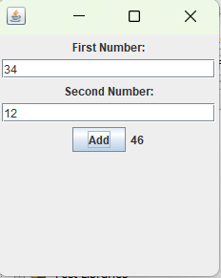
Q3. Write a program using JPasswordField to accept password from user and if the length is less than 6 characters then error message should be displayed "Password length must be >6 characters".

import javax.swing.*;
import java.awt.event.*;

public class J_pass {
public static void main(String[] args) {
JFrame f = new JFrame("Password Field Example");
// Creating PasswordField and label
JPasswordField value = new JPasswordField();
value.setBounds(100, 100, 100, 30);
value.setToolTipText("Password length must be >6 characters");
JLabel l1 = new JLabel("Password:");
l1.setBounds(20, 100, 80, 30);
// Adding components to frame
f.add(value);
f.add(l1);
f.setSize(300, 300);
f.setLayout(null);
f.setVisible(true);
}
}

OUTPUT:-
